Runner Live Tracking App — PRD, ERD & API Contract (v1)
Oct 3, 2026 · @syaqirah

Overview
A live tracking app for runners and the people cheering them, inspired by the KLSCM app. First public release targets 31 Dec 2026 on iOS and Android.
Decisions made so far:
- Three roles: Runner, Cheer, Organizer.
- Two modes: official event (bib, checkpoints, ranking) and free run (no event, share by link).
- Three tracking sources: phone GPS, LTE smartwatch GPS, and checkpoint cameras reading bib numbers (OCR). No RFID mats in v1.
- Mobile: Flutter, one codebase for iOS and Android. Watch apps are native (SwiftUI, Kotlin).
- Backend: Laravel API with Laravel Reverb for realtime, plus an admin web for organizers.
- One scope (v1), built in order. The December release is phone-only; OCR, finish video and watch apps follow by March 2027.

Roles and modes
One account can act as Runner and Cheer; Organizer is a separate permission granted per event.
Role | What they do | Where
Runner | Joins an event with a bib or starts a free run, gets tracked, sees splits and results | Mobile app, watch
Cheer | Follows runners by name, bib, QR or share link; sees live map, ETA and ranking; sends cheer messages | Mobile app, public web link
Organizer | Creates events, uploads the route, imports the bib list, places checkpoints, publishes results | Admin web

Mode | Has | Does not have
Event | Bib, categories, checkpoints, ranking, finish video, e-cert | —
Free run | Live tracking, share link, cheer messages, personal stats | Bib, ranking, checkpoints
Both modes use the same activities record. An activity with an event_id is an event run; without one it is a free run.

How it works
On race day every runner ends up on the same live map, whether they carry a phone, wear an LTE watch, or carry nothing but a bib.
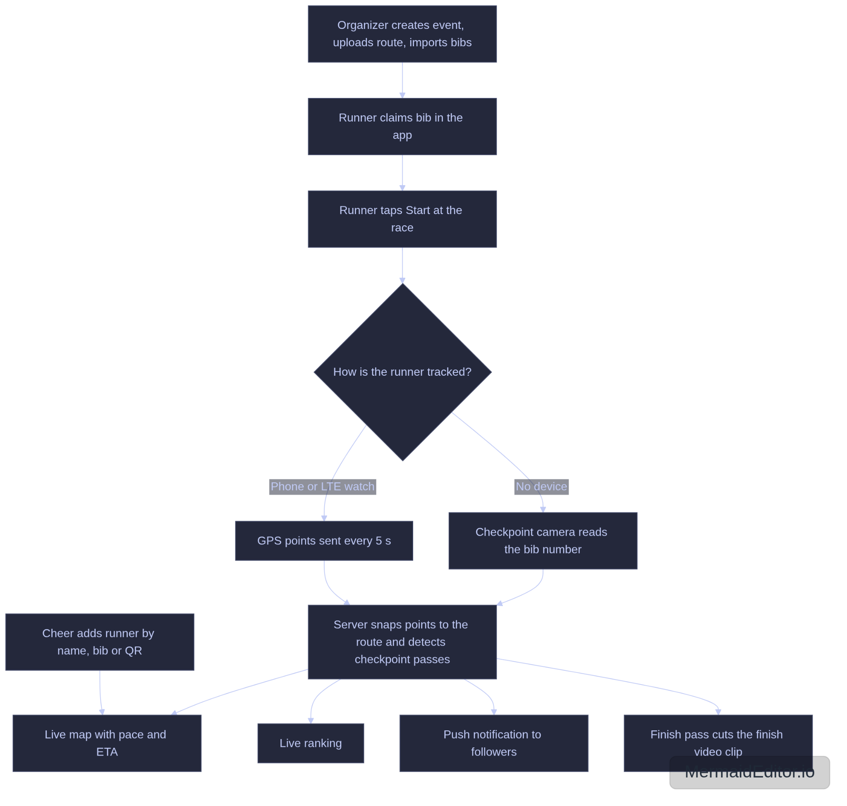
The system has four clients talking to one Laravel backend.
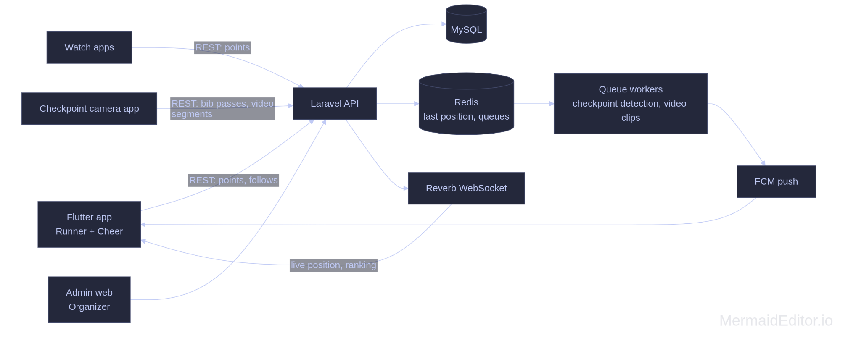

v1 feature scope
Everything below is v1. The Release column says which build it ships in: R1 is December 2026, R2 is February 2027, R3 is March 2027.
Feature | Role | Release
Sign up, login, profile (email + Google/Apple sign-in) | All | R1
Create event, upload route GPX, set categories and schedule | Organizer | R1
Import participants and bib numbers by CSV | Organizer | R1
Place checkpoints on the route (virtual geofences) | Organizer | R1
Join event by bib number + verification code | Runner | R1
Start, pause, finish a run with background GPS | Runner | R1
Free run with share link | Runner | R1
Offline queue for GPS points, battery saver mode | Runner | R1
Privacy setting: public, link only, off | Runner | R1
SOS button sending location to organizer | Runner | R1
View route and schedule | Runner, Cheer | R1
Add runner by name, bib, or QR scan | Cheer | R1
Live map of followed runners with pace and ETA | Cheer | R1
Push notification when a runner passes a checkpoint or finishes | Cheer | R1
Live ranking and unofficial results, overall and by category | All | R1
Race statistics: splits, pace chart, distance | Runner | R1
Cheer messages to a runner | Cheer | R2
Checkpoint camera app reading bib numbers (OCR) | Organizer | R2
Finish line video clip per runner | Runner, Cheer | R2
Official results publish, e-certificate | Organizer, Runner | R2
Selfie frames and share card | Runner, Cheer | R3
Apple Watch and Wear OS apps (LTE live, GPS-only sync later) | Runner | R3
Out of v1: RFID mats, timing company integrations, payments and race registration.

Fun to have (idea pool)
None of these are committed. Add a row for any idea; anything picked up gets moved into the table above with a release.
Idea | What it does | Effort | From
Voice cheers | Cheer records a short voice note; runner hears it in their earphones mid-run | Medium | Claude
Cheer spots | Map of good places to stand, with the time your runner will pass each one | Medium | Claude
Meet me after | Runner drops a pin after finishing so supporters can find them | Low | Claude
Pacer tracking | Follow the official pacers and see if your runner is ahead or behind | Low | Claude
Target time alerts | Runner sets a goal time; app warns when pace drops below it | Low | Claude
Photo matching | Event photographers upload photos; bib OCR tags them to each runner | High | Claude
Badges and streaks | Rewards for events finished, personal bests, free runs per week | Medium | Claude
Training groups | Private leaderboard for a running club's weekly runs | Medium | Claude
Heat and weather alert | Warns runners and organizer when conditions turn risky | Low | Claude
Export to Strava | Send a finished run to Strava | Medium | Claude

Tracking architecture
Every source writes to the same two tables: track_points for raw positions and checkpoint_passes for split times. The live map never cares which source a point came from.
Source | Sends | Live? | Covers
Phone GPS | Position every 5 s (15 s in battery saver), batched | Yes | Runners carrying a phone
LTE watch GPS | Same payload as phone | Yes | Runners with a cellular watch, no phone
GPS-only watch | Recorded track uploaded after the run | No | Stats only, not live
Checkpoint camera (bib OCR) | Bib + timestamp + checkpoint | At checkpoints | Runners with no device
How the pieces work:
- Ingest. The app posts batches of points. The server snaps each point to the route and stores distance along the route in metres.
- Virtual checkpoints. When snapped distance crosses a checkpoint's distance, the server writes a checkpoint_passes row with source gps.
- Camera checkpoints. A phone on a tripod runs the checkpoint app, detects bibs, reads the number and posts a pass with source ocr. Low confidence reads go to a review queue in admin.
- Estimated position. A runner with no live GPS is shown at last pass distance plus pace times elapsed time, capped at the next checkpoint. The map marks these dots as estimated.
- Broadcast. Reverb pushes position and pass events to followers. Clients fall back to polling every 10 s if the socket drops.
- Finish video. The finish camera records continuously in 60 s segments with server-synced time. On a finish pass, a queue job cuts 10 s before to 5 s after with ffmpeg and attaches the clip to the activity.
The bib barcode is used for race kit check-in and for Cheer scan-to-follow, not for reading runners in motion; the printed number is what the camera reads.

Tech stack and work split
Layer | Choice | Owner (proposed)
API | Laravel + Sanctum tokens | Qirah
Realtime | Laravel Reverb (WebSocket), Redis for queues and last-position cache | Qirah
Database | MySQL 8 with spatial columns | Qirah
Admin web | Laravel + Blade or Inertia, MapLibre for the route editor | Qirah
Mobile app | Flutter; geolocator + a foreground service for background GPS | Arep
Maps | MapLibre with OpenStreetMap tiles | Arep
Push | Firebase Cloud Messaging (covers APNs) | Arep (client), Qirah (server)
Bib OCR | On-device text recognition (ML Kit) in the checkpoint app, server validates against the bib list | Qirah
Video | ffmpeg on a queue worker, object storage for clips | Qirah
Watch apps | SwiftUI (watchOS), Kotlin + Compose (Wear OS) | Qirah (watchOS), Arep (Wear OS)
Hosting needs a VPS, not shared hosting: Reverb, queue workers and ffmpeg all need long-running processes.
The owner column is a proposal. Both test on their own devices: Qirah on iOS, Arep on Android.

ERD
Sixteen tables. All have id, created_at, updated_at; those are left out below.
Table | Key columns | Relationships
users | name, email, password, avatar_url, default_privacy | —
devices | user_id, platform, push_token | belongs to user
events | organizer_id, name, slug, starts_at, timezone, status (draft, published, live, finished) | belongs to user (organizer)
event_staff | event_id, user_id, role (admin, marshal, medic) | event ↔ user
races | event_id, name (e.g. 10 km), distance_m, start_at, cutoff_at | belongs to event
routes | race_id, gpx_path, polyline (LINESTRING), length_m | one per race
checkpoints | race_id, name, type (start, split, finish), distance_m, location (POINT), radius_m | belongs to race
categories | race_id, name, gender, age_min, age_max | belongs to race
participants | race_id, category_id, bib, name, verify_code, user_id (nullable until claimed) | belongs to race; claimed by user
activities | user_id, participant_id (nullable), race_id (nullable), mode (event, free), status, privacy, share_token, started_at, finished_at, distance_m, duration_s | belongs to user; optional participant
track_points | activity_id, recorded_at, lat, lng, accuracy_m, speed_mps, route_distance_m, source (phone, watch) | belongs to activity
checkpoint_passes | participant_id, checkpoint_id, passed_at, source (gps, ocr, manual), confidence, elapsed_s | participant ↔ checkpoint
follows | follower_id, participant_id (nullable), activity_id (nullable), notify | user follows a participant or a free-run activity
cheer_messages | sender_id, activity_id, body, sent_at | belongs to activity
media | activity_id, type (finish_video, photo, frame), path, checkpoint_id, captured_at | belongs to activity
sos_alerts | activity_id, lat, lng, status (open, acknowledged, closed), handled_by | belongs to activity
Notes:
- participants exists before the runner has an account. The organizer imports bib, name and category; the runner claims it in the app with bib + verify_code.
- Unique index on (race_id, bib) and on (participant_id, checkpoint_id). When GPS and OCR both report a pass, OCR wins for the timestamp.
- track_points grows fast: about 720 rows per runner per hour at 5 s. Index (activity_id, recorded_at), partition by month, and keep each runner's latest position in Redis so the live map never queries this table.
- Results are a query over checkpoint_passes at the finish checkpoint, ranked by elapsed_s. No separate results table until official results need freezing.

API contract
Base path /api/v1, JSON, Bearer token (Sanctum). Times are ISO 8601 in UTC. Errors return { "message", "errors" } with the matching HTTP status.
Method | Path | Purpose | Auth
POST | /auth/register | Create account | Public
POST | /auth/login | Get token | Public
POST | /auth/social | Google or Apple sign-in | Public
GET, PATCH | /me | Profile and default privacy | User
POST | /devices | Register push token | User
GET | /events | List published events | Public
GET | /events/{slug} | Event with races, schedule | Public
GET | /races/{id}/route | Route polyline and checkpoints | Public
GET | /races/{id}/participants?q= | Search by name or bib | Public
GET | /races/{id}/leaderboard?category=&checkpoint= | Live ranking | Public
POST | /participants/claim | Claim a bib with bib + verify_code | User
POST | /activities | Start a run (mode, optional participant_id) | User
PATCH | /activities/{id} | Pause, resume, finish, change privacy | Owner
POST | /activities/{id}/points | Batch upload of track points | Owner
GET | /activities/{id} | Stats, splits, media | Owner or allowed viewer
GET | /share/{token} | Public view of a link-only activity | Public
GET, POST | /follows | List or add followed runners | User
DELETE | /follows/{id} | Unfollow | User
GET | /follows/live | Latest position, pace, ETA of everyone I follow | User
POST | /activities/{id}/cheers | Send a cheer message | User
POST | /activities/{id}/sos | Raise SOS with location | Owner
POST | /checkpoints/{id}/passes | Checkpoint app posts an OCR read (bib, passed_at, confidence) | Event staff
POST | /checkpoints/{id}/segments | Finish camera uploads a video segment | Event staff
Points batch body, the hottest endpoint:
{
"source": "phone",
"points": [
{ "t": "2026-12-06T22:30:05Z", "lat": 3.1478, "lng": 101.6953, "acc": 6.0, "spd": 3.1 }
]
}
The server accepts up to 500 points per call, ignores duplicates by (activity_id, t), and returns { "accepted": n, "last_t": "..." } so the app can clear its offline queue.
Realtime channels (Reverb):
Channel | Events | Who can join
race.{id} | leaderboard.updated, race.status | Public
participant.{id} | position.updated, checkpoint.passed, finished | Public if runner privacy is public; followers otherwise
activity.{id} | position.updated, cheer.received | Owner and allowed viewers
event.{id}.staff | sos.raised, ocr.review | Event staff
Organizer admin runs on web session routes, not this API, except the two staff endpoints used by the checkpoint app.

Build order
R1 ships to both stores by 31 Dec 2026; each row is done only when its exit check passes.
When | Build | Exit check
5–11 Oct | Developer accounts registered (Apple, Google Play). Background GPS spike in Flutter | A 5 km run with screen off logs an unbroken track on one iPhone and one Android
12–31 Oct | Laravel API: auth, events, races, routes, checkpoints, participants import. Admin web | Organizer creates an event with a GPX route and 50 imported bibs
1–21 Nov | Flutter app: auth, claim bib, start and finish run, points upload with offline queue, free run | Points from a real run appear in the database with route distance
22 Nov–5 Dec | Follow, live map, checkpoint passes, leaderboard, Reverb, push notifications | A Cheer phone sees a Runner phone move and gets a checkpoint notification
6–13 Dec | SOS, privacy, battery saver, stats screens. Play closed testing starts | 12 testers enrolled on Play; TestFlight build out
14–20 Dec | Pilot: one real group run, 10 or more runners | No lost tracks; issues list triaged
21–31 Dec | Fixes, store listings, submit | R1 live on App Store and Play
Jan–Feb 2027 | Checkpoint camera app with bib OCR, review queue, finish video, cheer messages, official results, e-cert | R2: a runner with no device gets splits and a finish clip
Mar 2027 | watchOS and Wear OS apps, selfie frames | R3: an LTE watch runner is tracked live with no phone
The first row is the gate for everything else. If background GPS is not reliable with geolocator, decide that week whether to buy a dedicated background location plugin.

Risks and open questions
Risk | Effect | Mitigation
OS kills background GPS on long runs | Gaps in the live track | Spike in week 1; foreground service on Android, "Always" location permission and background mode on iOS
Mobile network congested on race day | Live map lags | Offline queue, batch upload, estimated position between updates
Store review and Play closed testing take weeks | Miss 31 Dec | Register accounts now; start Play testing by 6 Dec; submit iOS by 21 Dec
Location data is personal data under PDPA | Legal exposure | Consent screen, privacy default set to link only, delete-my-data option, retention limit on raw points
OCR misreads bibs (folded, covered, dark) | Wrong split times | Validate against the bib list, confidence threshold, manual review queue
Two people, part-time, four client apps | Scope slips | Fixed build order above; nothing from R2 or R3 starts before R1 is live

